**Hospital Queue**

After BPJS being published in Jakarta, **Quasar** **Hospital** get so many patient. To make it easier to manage its Hospital, the CTO of the hospital hire some programmers. You as one of the programmer of **Quasar** **Hospital** are asked to create a queue program with requirement below:

1. We don’t know the numbers of the patient. So, the apps must be developed using Linked List.
2. We have four class of hospital room (Basic, VIP, Super VIP, Emergency)
3. The queue must be arranged in priority as below:
   1. Emergency always in front of Super VIP, VIP and Basic.
   2. Basic always behind VIP.
   3. VIP always behind Super VIP.
   4. Super VIP always in front of VIP and Basic.
4. You are suggested to use Double Linked List Queue.
5. This application has menu to show patient list.

Please look image below for more information or run the **QuasarHospital**.exe to have an insight.

Using linked list (**Struct** **Given**):

struct Quasar{

char patient_name[25];

int priorityLevel;

int age;

struct Quasar *next, *prev;

}*head, *tail;

**Main Menu:**

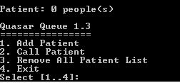

**Menu 1 - Add Patient:**

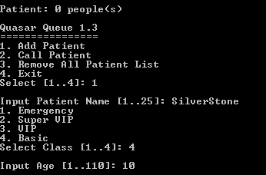

Validate:

1. Full name must be more than 1 character and less than 25 characters.
2. Class must between 1 and 4.
3. Age must between 1 and 110.

**Menu 2 - Call Patient:**

If patient exist:

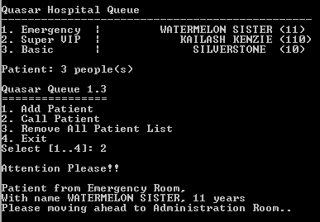

If no patient:

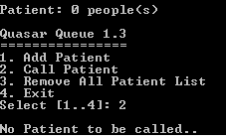

**Menu 3 – Remove All Patient List:**

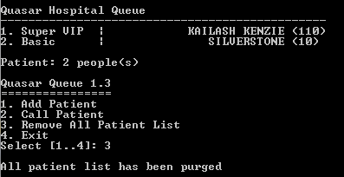

**Menu 4 – Exit:**

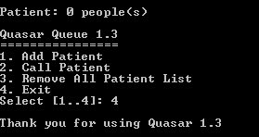

**Thank you and Good Luck.**